H.T No
Regulations:
A20

Sreenidhi Institute of Science and Technology
(An Autonomous Institution)
Code No: 8HC11 Date: 19-Feb-2025 (FN)

B.Tech I-Year II- Semester External Examination, February-2025 (Supplementary)
ADVANCED CALCULUS AND COMPLEX VARIABLES (EEE and ECE)

Time: 3 Hours Max.Marks:70

Note: a) No additional answer sheets will be provided.
b) All sub-parts of a question must be answered at one place only, otherwise it will not be valued.
c) Missing data can be assumed suitably.
Bloom's Cognitive Levels of Learning (BCLL)

Remember | L1 | Apply | L3 | Evaluate | L5
Understand | L2 | Analyze | L4 | Create | L6

Part - A Max.Marks:20

Answer all QUESTIONS.

 |  | BCLL | CO(s) | Marks
1 | State Newton's law of cooling | L1 | CO1 | [2M]
2 | Solve (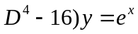 | L2 | CO2 | [2M]
3 | Evaluate 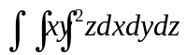where limits x=1 to 2, y=2 to 3 , z=3 to 4 | L3 | CO3 | [2M]
4 | State Stokes theorem. | L1 | CO4 | [2M]
5 | State Cauchy-Riemann equations in Cartisian form. | L1 | CO5 | [2M]
6 | Define Translation and Inversion of Conformal Mapping. | L3 | CO6 | [2M]
7 | Solve the differential equation | L2 | CO2 | [2M]
8 | Evaluate 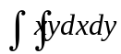 , where limits x=0 to 1, y=0 to x | L2 | CO3 | [2M]
9 | Expand 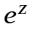as Taylor’s series in powers of | L3 | CO4 | [2M]
10 | Define essential and Removable singularity with an example. | L2 | CO5 | [2M]

Part – B Max.Marks:50
ANSWER ANY FIVE QUESTIONS. EACH QUESTION CARRIES 10 MARKS.

 |  |  | BCLL | CO(s) | Marks
11. | a) | Solve  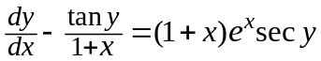 | L3 | CO1 | [5M]
 | b) | A body originally at 80°C cools down to 60°C in 20 minutes, the temperature of the air being 40°C. What will be the temperature of the body after 40 minutes from the original? | L4 | CO1 | [5M]
12. | a) | Solve (D+4)y = Cosecx | L3 | CO2 | [5M]
 | b) | (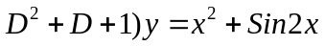+20 | L3 | CO2 | [5M]
13. | a) | Evaluate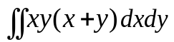 over the area between 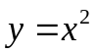and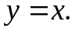 | L2 | CO3 | [5M]
 | b) | By changing the order of the integration, evaluate 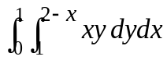 | L4 | CO3 | [5M]
14. |  | Verify Greens theorem inn the pane  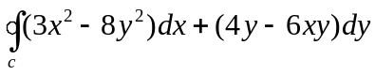,where C is the boundary for the region enclosed by 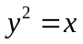 and x²=y. | L2 | CO4 | [10M]
15. | a) | Show that the function 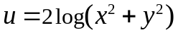 is harmonic and find its harmonic conjugate. | L2 | CO5 | [4M]
 | b) | Find the bilinear transformation which maps  the points 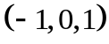 in theplane onto the points 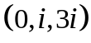 in the plane | L3 | CO5 | [6M]
16. | a) | Evaluate 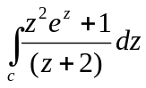 where C: |z|=3 | L3 | CO6 | [5M]
 | b) | What is the region of the W-plane into which the rectangular region in the  z-plane bounded by x=0,y=0,x=1 and y=2 is mapped under transformation  W=z+(z-i) | L3 | CO6 | [5M]
17. | a) | Solve 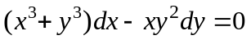 | L3 | CO1 | [4M]
 | b) | Find the general solution of 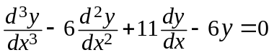 | L2 | CO2 | [3M]
 | c) | Evaluate | L2 | CO3 | [3M]
18. | a) | Find the work done in moving a particle in the force 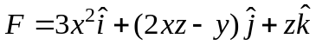along the straight line from 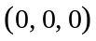 to 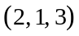 | L3 | CO4 | [4M]
 | b) | Show that 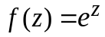is analytic everywhere in the complex plane. | L3 | CO5 | [3M]
 | c) | Find the poles and residues of the following function  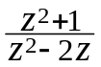 | L3 | CO6 | [3M]

-- 00 -- 00 –

